**Introduction**

To optimize retail strategies, it is crucial to understand how customers buy chips. This report examines chip purchasing patterns in depth, covering various factors that influence customer behavior and preferences. The report also provides actionable insights to improve sales and customer satisfaction.

**Data Understanding and Preparation**

The analysis was based on a rigorous data preparation process, which included:

**Data Cleaning:** This involved converting data types, removing duplicates, fixing inconsistencies, and filling missing and null values.

**Data Merging:** Transaction data and customer data were combined into a single dataset for comprehensive analysis.

**Data Extraction:** Only the relevant “Chips data” was selected from the merged dataset for further analysis.

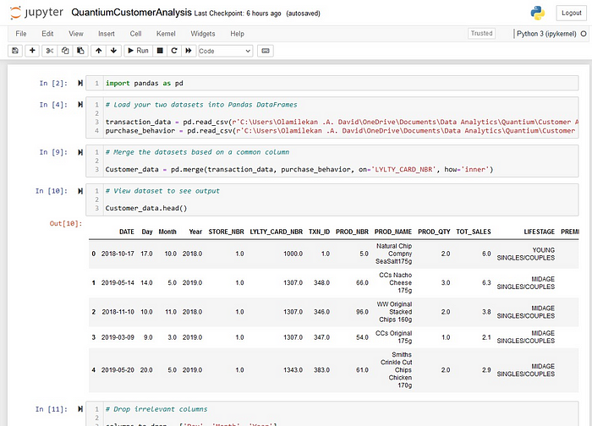

***Key Findings***

**Impact of Product Quantity**

**Product Quantity Analysis:** The analysis showed that customers preferred smaller quantities of chips, especially 2 units per sale, which sold millions of units. A quantity of 1 also had high sales, reaching hundreds of thousands of units.

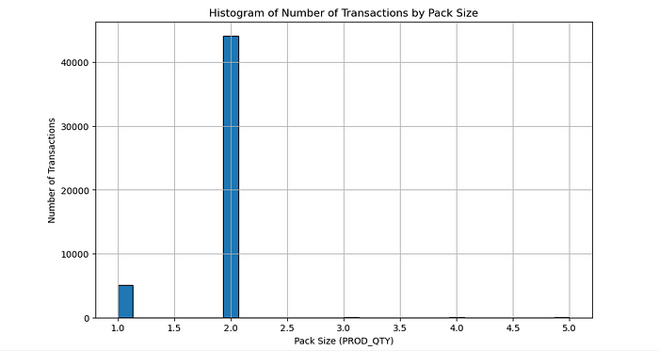

**Impact of Specific Products**

**Top-Selling Products:** The analysis identified “Dorito Corn Chips Supreme 380g” as the best-selling product, with an impressive 38,764 sales. A table shows the top ten best-selling products.

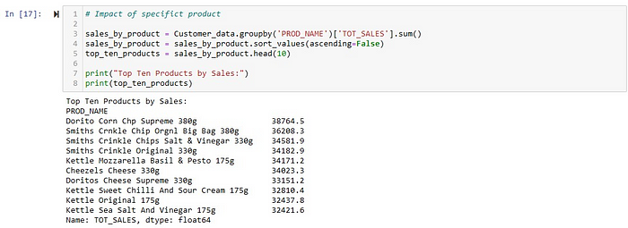

**Sales Distribution by Stores**

**Store Sales Analysis:** The analysis ranked stores by total sales and found that “Store 226” had the highest sales. A table displays the top ten stores by sales.

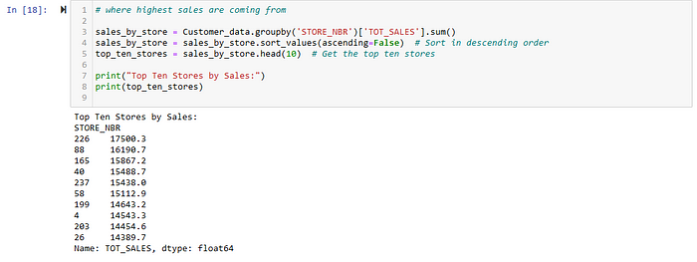

**Lifestage and Premium Customers Sales by Customer Segments:** A bar chart illustrates total sales by customer segments. The main contributors were “Budget — Older Families,” “Mainstream — Young Singles/Couples,” and “Mainstream — Retirees.”

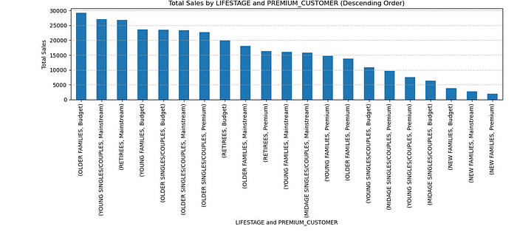

**Average Units per Customer by Lifestage and Premium Customer Unit Price Analysis**: The analysis revealed that “Mainstream Midage and Young Singles/Couples” were willing to pay more per packet of chips than their “Budget” and “Premium” counterparts. *This trend could be explained by the possibility that premium shoppers chose healthier snacks and bought chips only for entertainment purposes.*

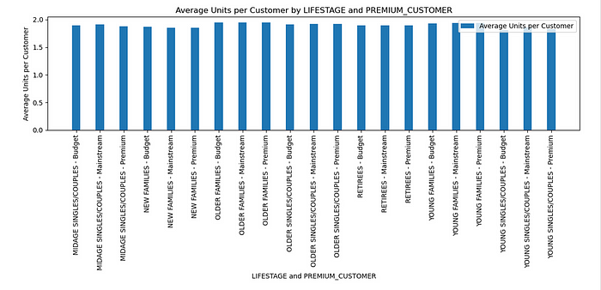

A t-test was performed to test the statistical significance of this difference. The results showed a p-value of 1.17, indicating that the unit price for mainstream young and mid-age singles and couples was significantly higher than that of budget or premium counterparts.

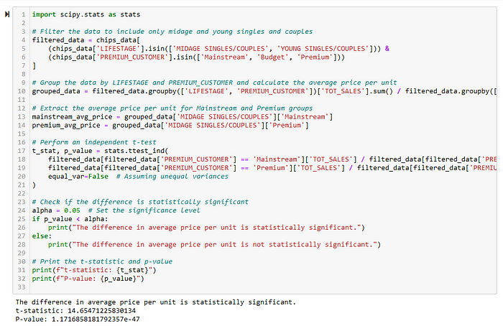

**Top Brands Preferred by Mainstream Young Singles/Couples Brand Preference:** The analysis also explored the “Mainstream Young Singles/Couples” segment in more detail and found that they favored certain brands over others. This insight is valuable for marketing and stocking decisions.

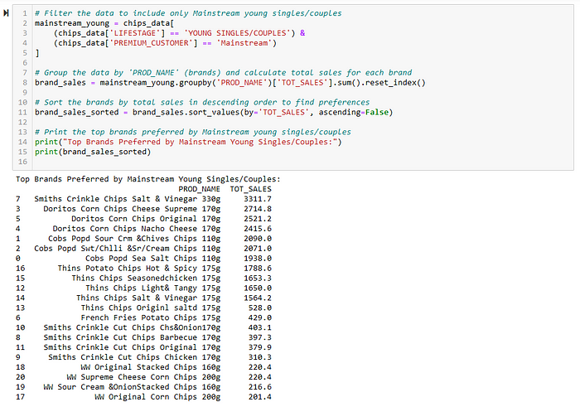

**Recommendations**

**Based on the analysis, the following recommendations are suggested:**

1. ***Product Stocking:*** To meet customer demand, ensure sufficient stock of chips with 2-unit and 1-unit packaging.

2. ***Promotion Strategies:*** To boost sales, focus promotional efforts on top-selling products, especially “Dorito Corn Chips Supreme 380g.”

3. ***Store Management:*** To maximize revenue, pay special attention to stores like “Store 226” that have high sales.

4. ***Targeted Marketing:*** To increase customer satisfaction, customize marketing campaigns to suit the preferences of “Mainstream Young Singles/Couples.”

5. ***Pricing Strategies***: To optimize profit, implement dynamic pricing strategies for different customer segments, especially for “Mainstream Midage and Young Singles/Couples.”

**Conclusion**

In summary, this report provides a thorough analysis of chip purchasing behavior and reveals important insights into customer preferences and trends. By applying these insights, the supermarket can tailor its strategies to enhance sales and customer satisfaction.